We are growing!

We are one of 9 mobile markets that was selected to receive funding and evaluation support from the Veggie Van Study. [SITE NAME] will be one of the community sites that we will partner with to launch a mobile market expected [APPROXIMATE MARKET LAUNCH DATE: e.g. Spring 2020]

If you are interested in using the mobile market, we want to hear from you so! Please fill out this [HYPERLINK TO INTEREST FORM] form so we can get your input and keep you up to date!

You can learn more about our mobile market at [LINK TO MOBILE MARKET WEBSITE].

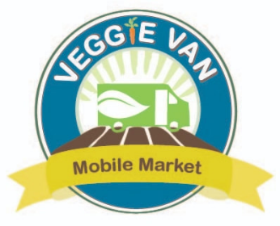

[INSERT MOBILE MARKET OR PARTNER AGENCY LOGO]

